It’s Bingo Time again!!!!!

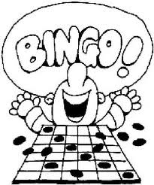
MONDAY, September 25th, 2017
Students-Invite your grandparents or a special guest to join you for Bingo!
THREE SESSIONS!!!
Session 1-9:00-10:15a.m.-Students in Grades 6, 7, 8 and AM Early -5’s and AM Preschool 4’s

Session 2-11:00-12:15 p.m.-Students in Grades 3, 4, 5

Session 3-1:30-2:45p.m. Students in Grades Kindergarten, 1, 2, PM Early 5’s and PM Preschool 4’s
**If students would like to leave Session 3 with their guest, a separate note MUST be turned into their Homeroom teacher on the day of Bingo. Sessions 1 and 2 will return to class following their Bingo Session
All guests should sign-in at the Parish Center Lobby. Students will meet their guests in the parish center lobby and proceed to the main gym for bingo. Siblings within the same session will play bingo together with their guest(s).
To accommodate the large numbers, there will be three bingo sessions. Some guests may need to participate in all three sessions if they have children in grades within the different sessions! Students can only play bingo during the designated session for their grade level. We would like for all students to have a guest when playing bingo. After bingo, students will return to class.
Please complete the form below and return to school by Friday, September 15th, 2017 with your YOUNGEST/ONLY CHILD.
Any questions, please call Ellen Miller at 433-1051 ext. 148
FAMILY NAME: _______________________________________
Student's Name: | Homeroom Teacher: | Grade: | Guest(s) Name(s): | Relationship:  (Grandparent, friend, parent, aunt, uncle, etc.)
Please return this form to the school with your youngest and only by Friday, September 15th, 2017

