Making a good use in Delivery food
Delivery food
You call to the restaurant, order the food than, in 30minutes your food will arrive to your house. You can even deliver it to school, river, or mountain.
What kinds of delivery food?
You can deliver almost every food in Korea.
1. Chicken 치킨
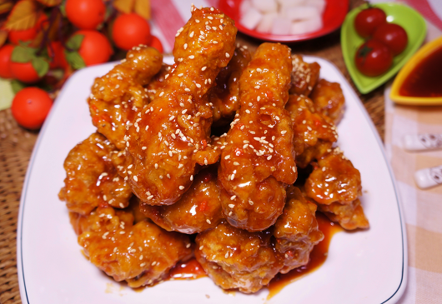
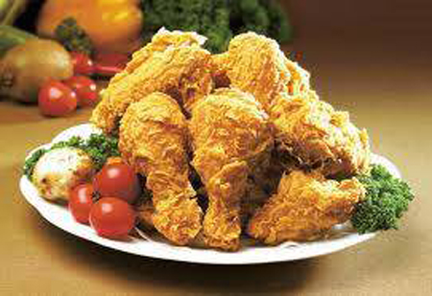
Brands: Kyochon Chicken
BBQ chicken
Gubnae chicken
BHC chicken
Naenae chicken

2.Pizza 피자
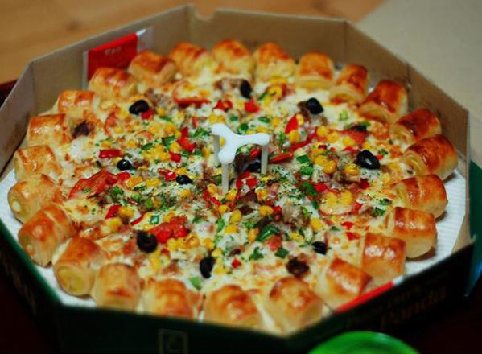
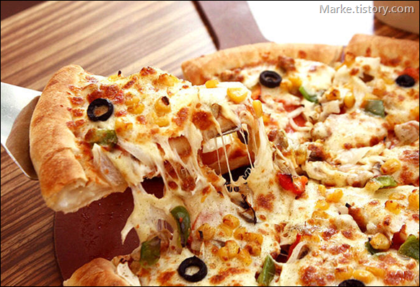
Brands: Domino Pizza
Mr. Pizza
Pizza Hut

3.Mc Donalds, Lotteria, Burger king, KFC

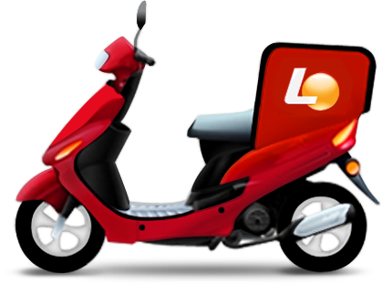


4 Chinese Food 중식( 짬뽕, 짜장면, 볶음밥)
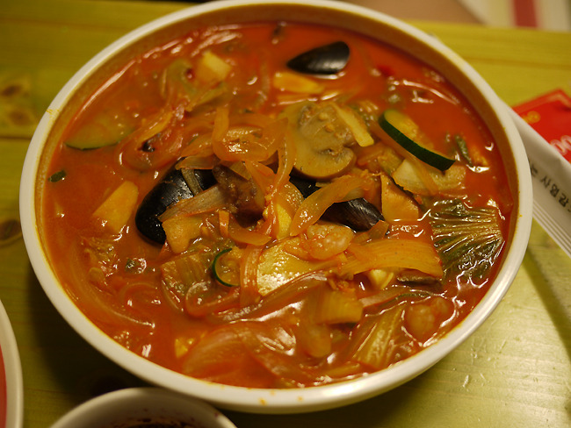
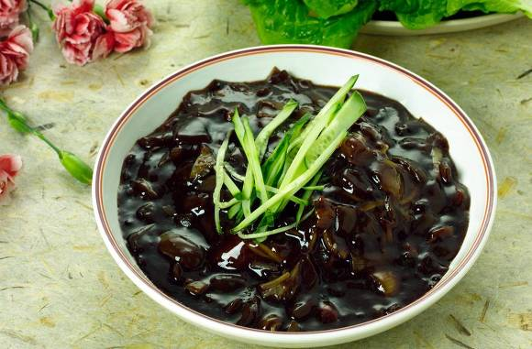
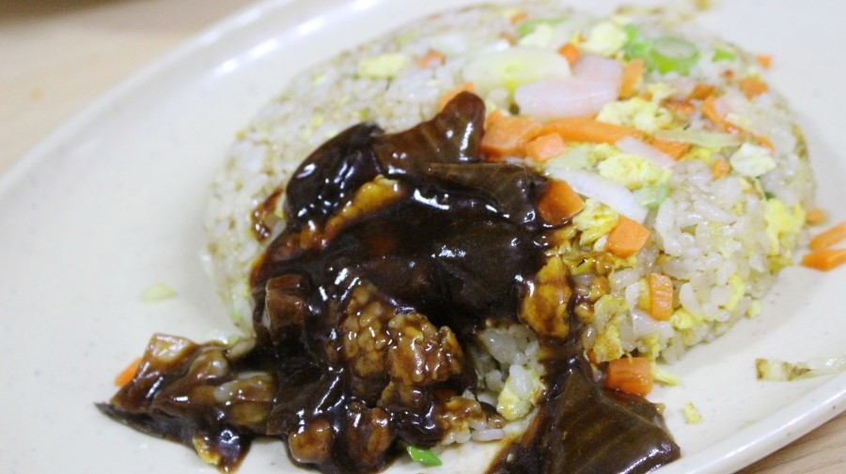

5.Gimbab,Tteokbboggi,Sundae,Fried dish 김밥, 떡볶이, 순대, 튀김
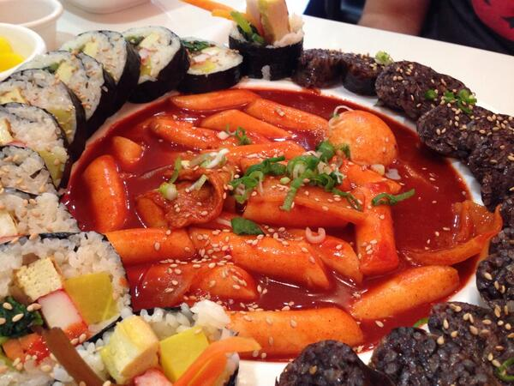
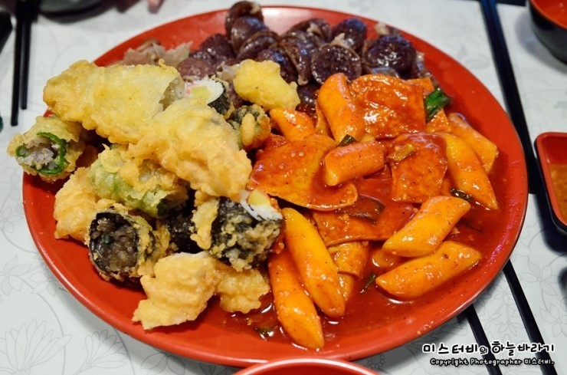

6.Sashimi 회
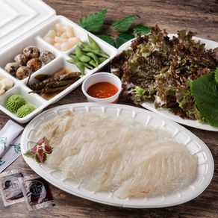

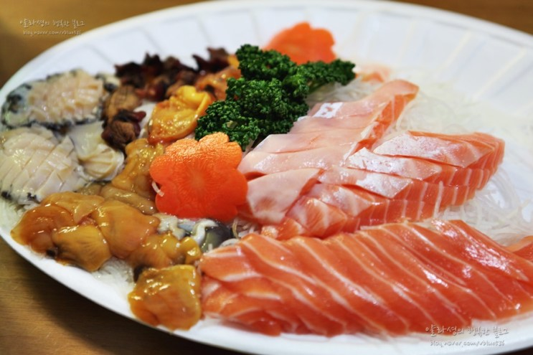

7.Bossam 보쌈
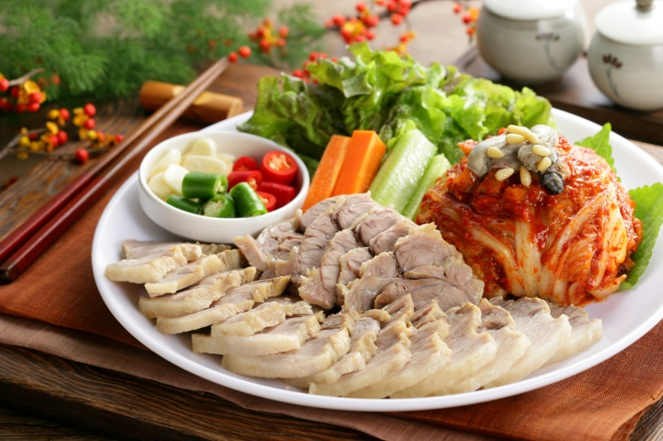
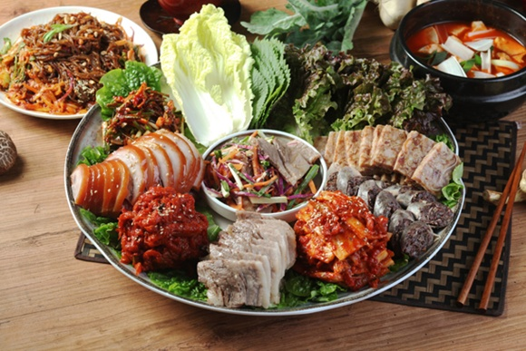

8.Pork Cutlet 돈까스
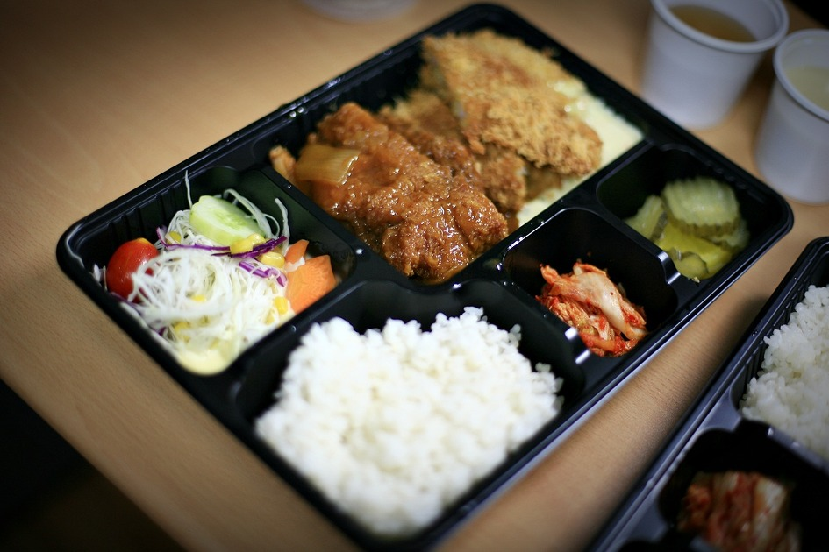
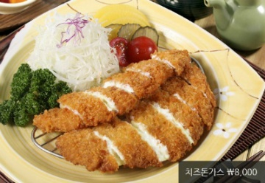

9.Korean Food 한식(감자탕, 부대찌개, 불고기, 돼지김치찜,된장찌개)
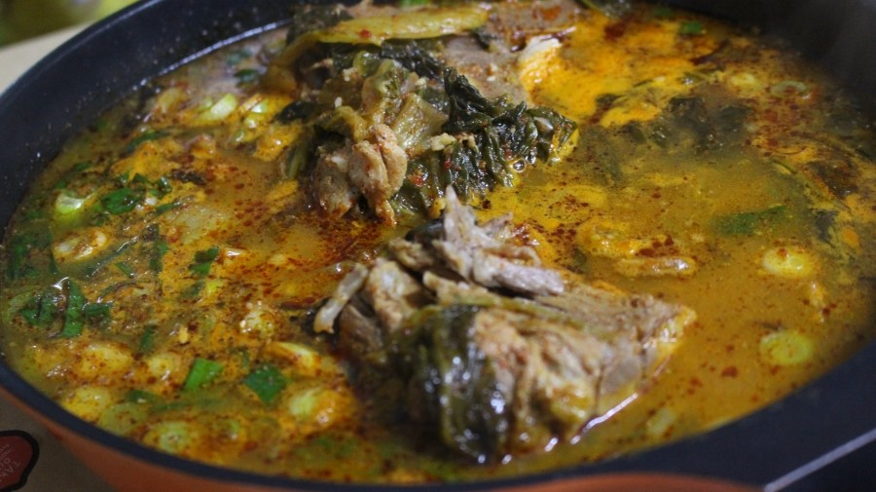
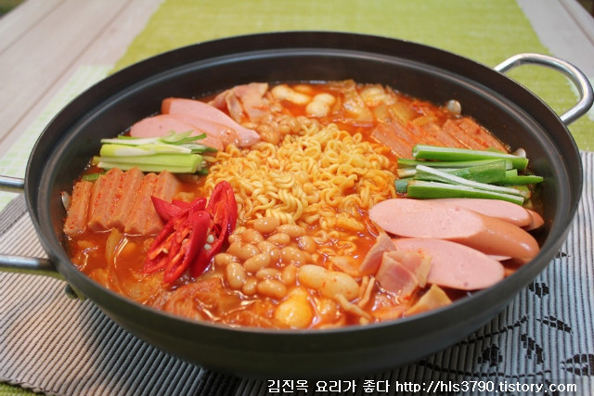
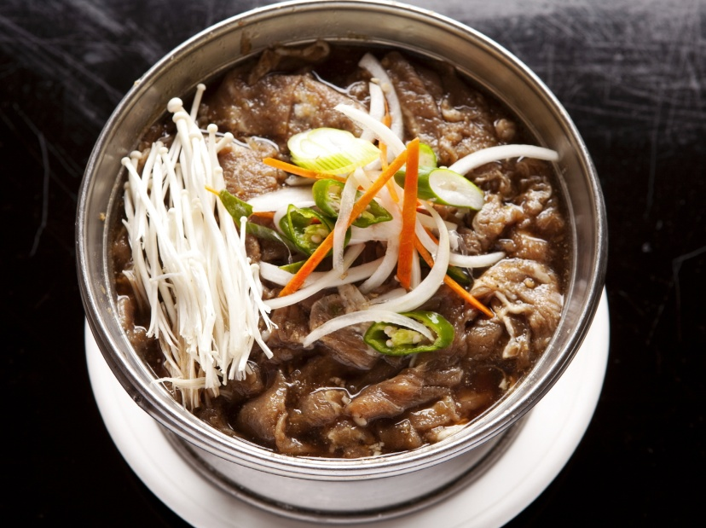
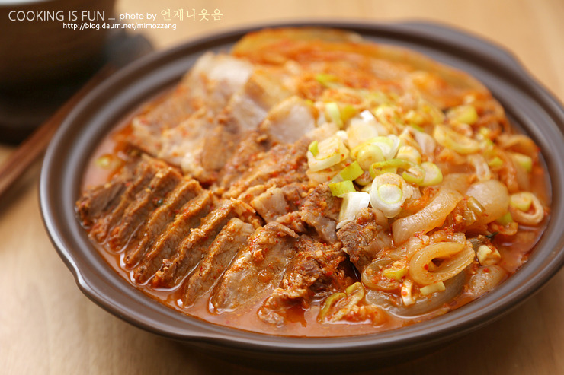
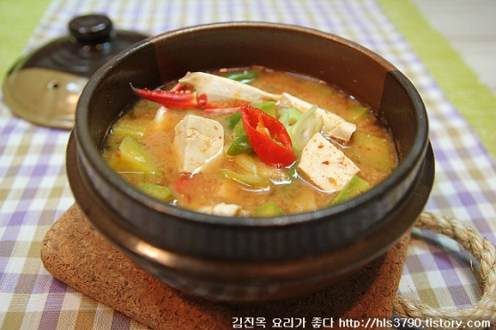
10.Itlay food(Pasta, Lazana)
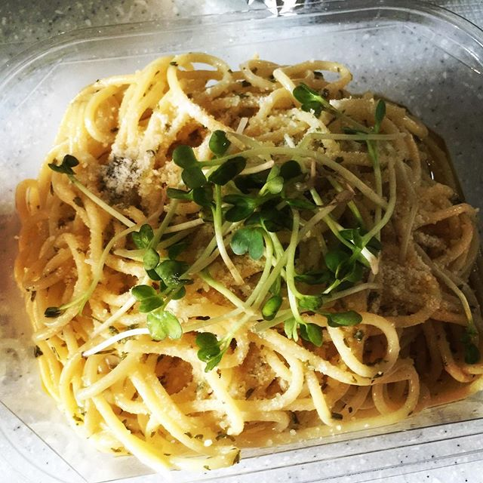
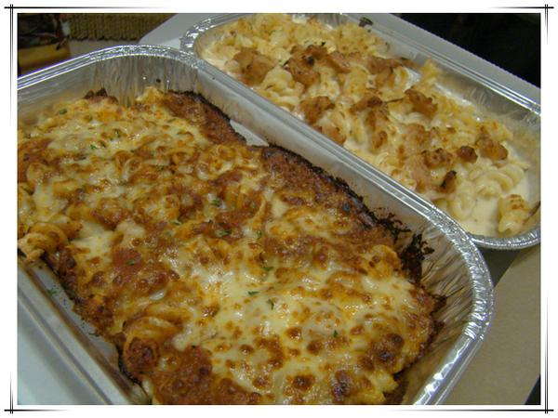
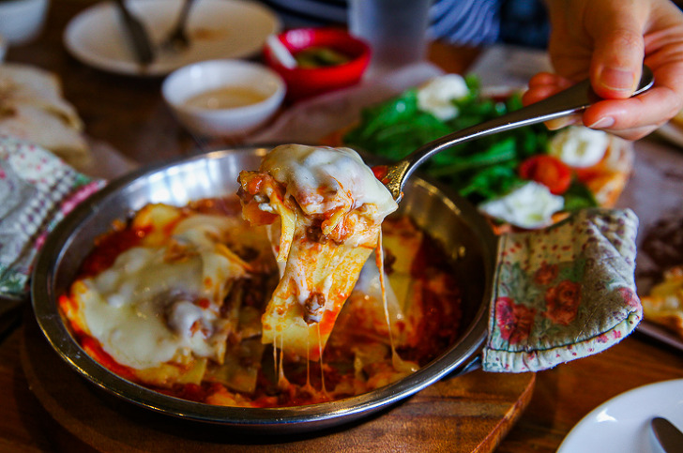

Useful Apps
배달의 민족
요기요(yogiyo)

