Scott W. Stern, LCSW

Empowering Psychotherapy, Addiction Treatment, Employer/Employee Assistance

407 Park Avenue South, Suite 23E, New York, New York 10016

212.935.7911

swspsychotherapy@gmail.com

www.Empower-sws.com

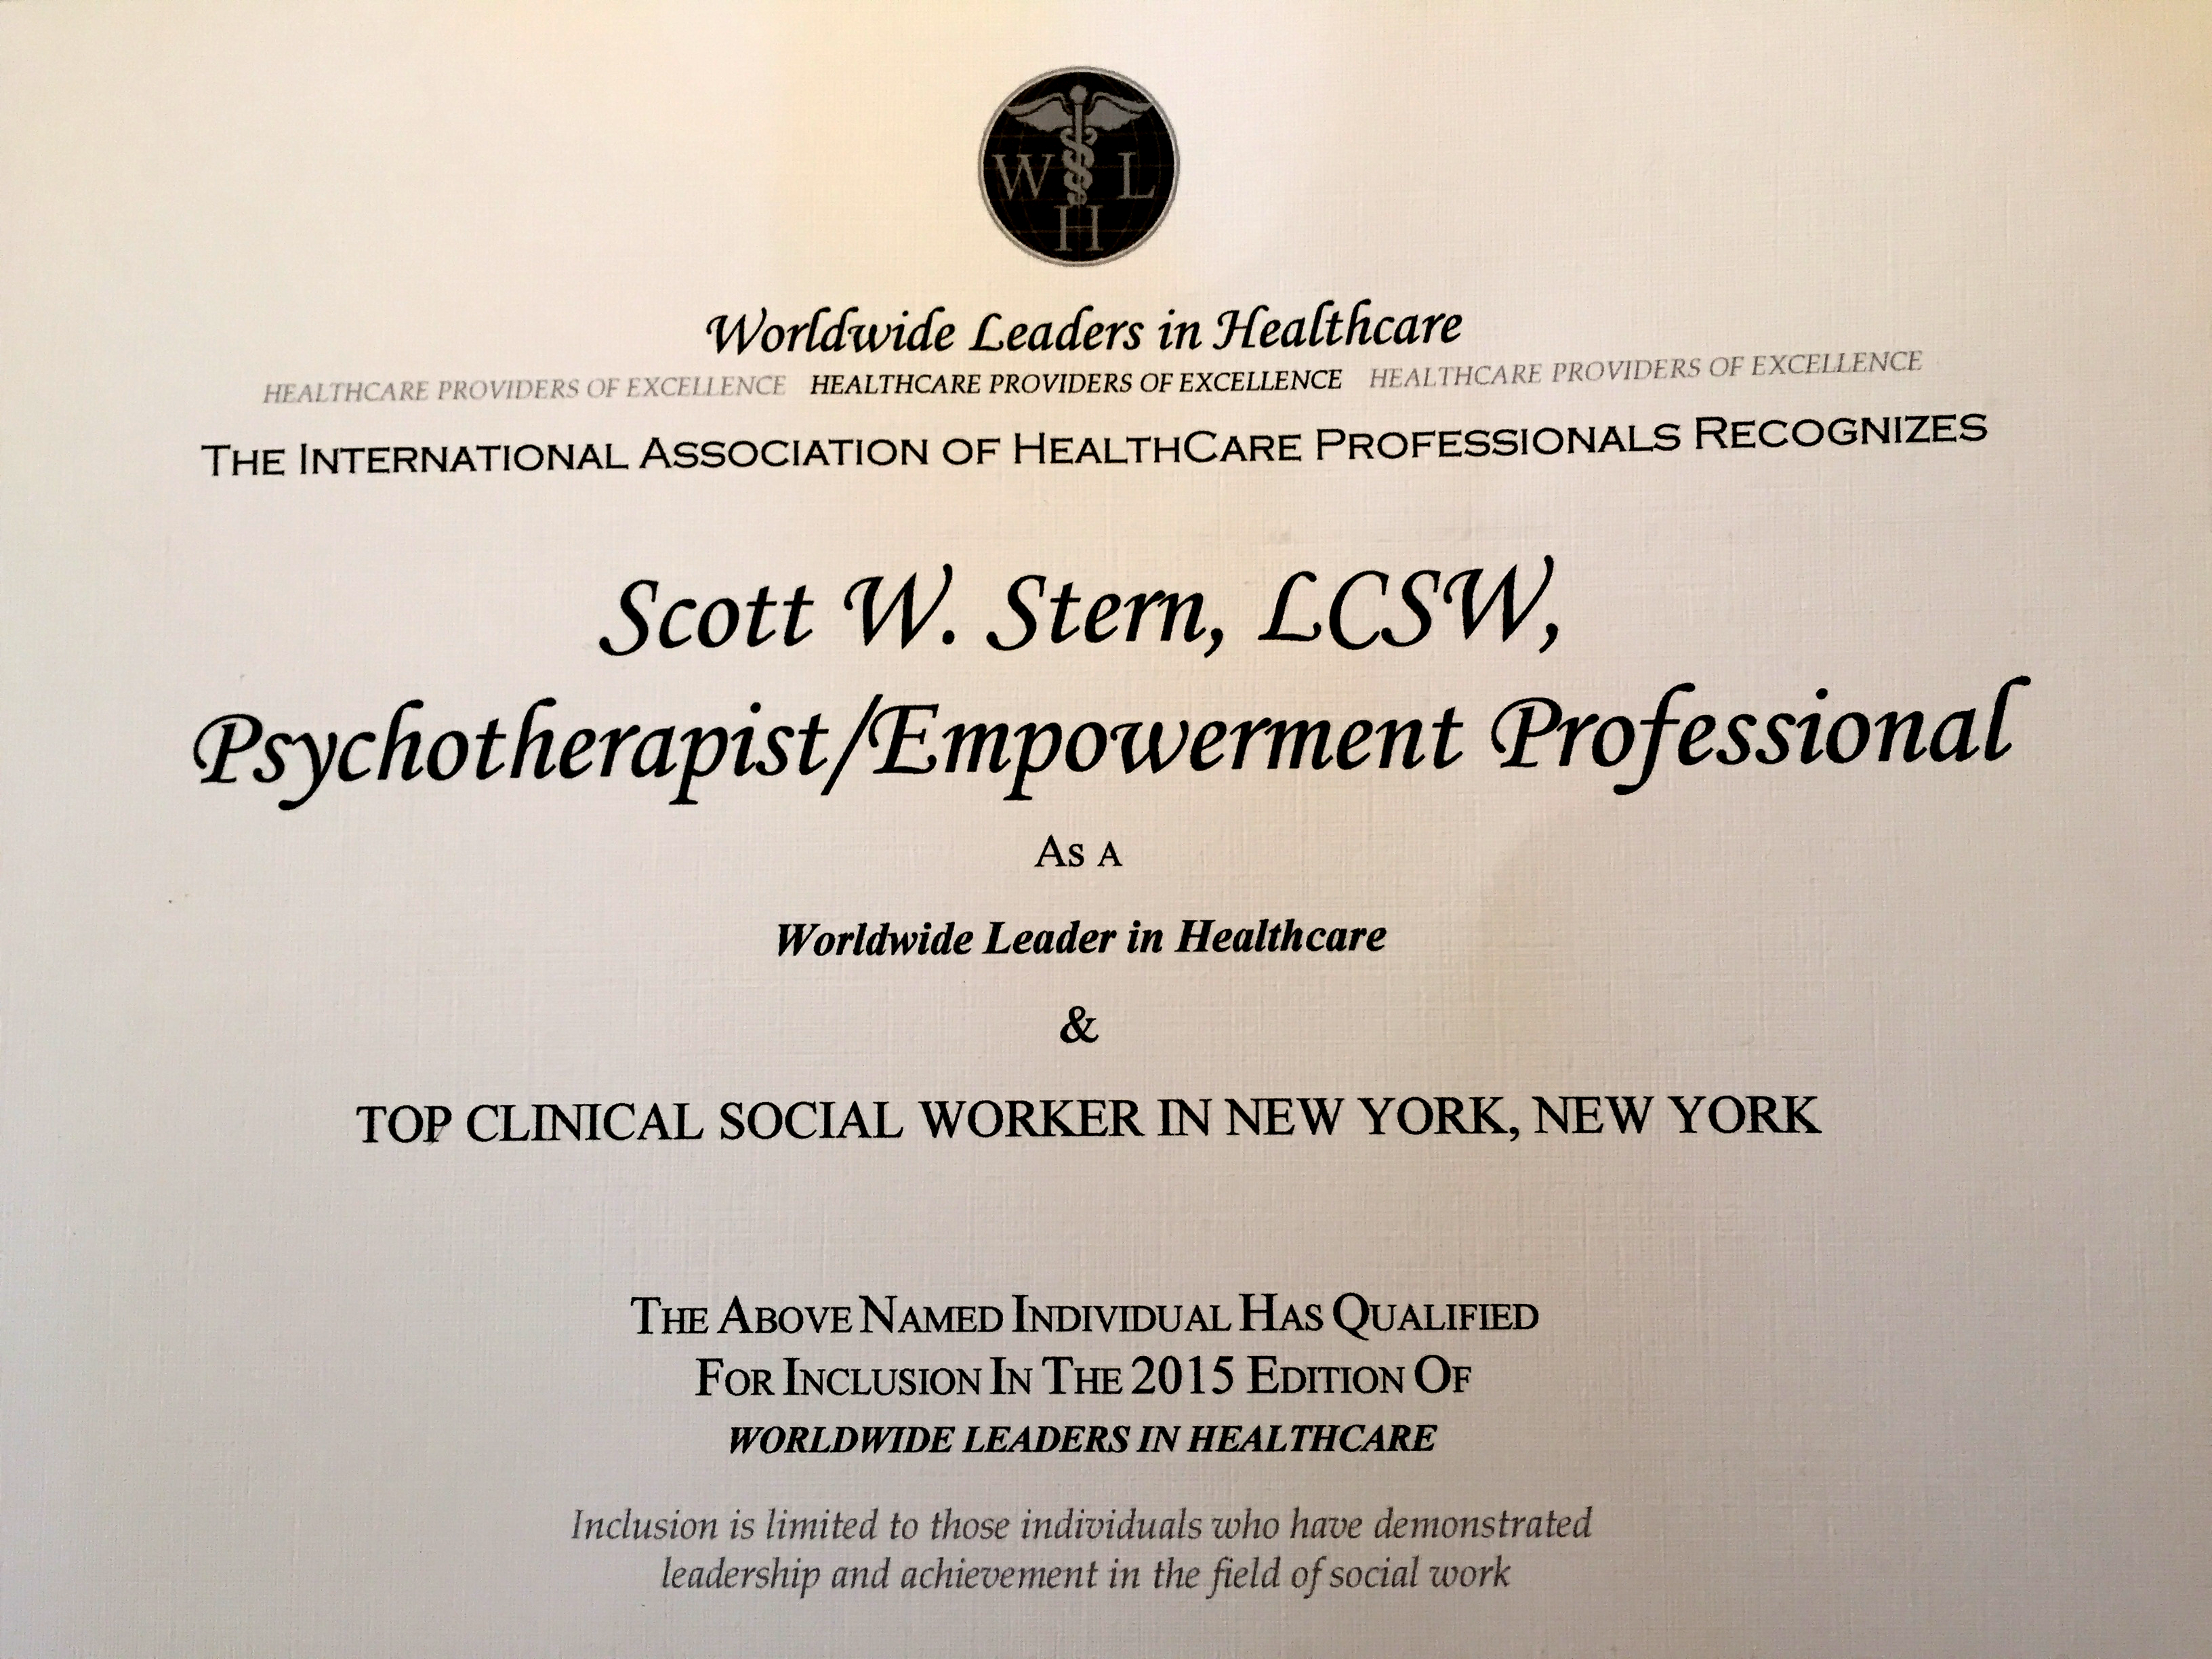

PROFILE

Management Experience in Social Work; Specialist in Mental Health and Substance Use Disorders; Private Practice Practioner; Licensed Clinical Social Worker (“R” Privilege) by New York State Education Department.

PROFESSIONAL EXPERIENCE
Private practice; integrative mental health and addictions treatment; clinical supervision; program development; case management; public speaking; freelance writing; employee assistance.
- Providing group, individual, couples, family, and adolescent counseling for MICA, HIV+, anxiety, bipolar, depression, severe borderline, OCD, PTSD and psychotic clients.
- Assessing employee mental status and substance substance use disorders for corporate clients.
- Managing Intensive Outpatient, Day Treatment, Ambulatory Detoxification, Harm Reduction, and MICA programs.
- Member of QA-PI (Quality Assurance-Performance Improvement) committee.
- Conducting morning rounds, clinical supervision, staff performance appraisals, hiring, disciplinary, and termination procedures.
- Public speaking and media consulting.
- Developing Integrative Member Care Plans, Program Development, Medicare Waste, Fraud and Abuse Prevention for MCO's, CMS and Healthcare Organizations.
- Writing published articles and book reviews covering addictions and mental health.
- Participating member and Recurring Presenter of NASW’s Addictions Institute Planning, Policy, Training and Development Committee/New York, New York.

“Top Clinical Social Worker in New York, NY”-- International Association of Healthcare Professionals (2015)
Private Practice (1993 – Present)
Award Winning Mental Health and Addictions Author, Editor and Contributing Writer (2011 – Present)
Contractor at CDC (Centers for Disease Control and Prevention) (2014 – 2015)
Healthfirst (2012 - 2013)
St. Vincent’s Hospital: The Maxwell Institute Addiction Treatment (2006 - 2012)
Harris Rothenberg International (2004 – 2006)
Full-time Private Practice (1996 – 2004)
The Washton Institute on Addictions (1993 – 1996) Continuum Health Partners: Beth Israel and St. Luke’s Roosevelt Hospital Centers_ (1987 – 1993)

PROFESSIONAL EXPERIENCE IN ADVERTISING, MARKETING AND SALES

Communications/copywriting; sales/marketing; campaign development and pre/post-production responsibilities.

- Creating broadcast and print campaigns for accounts targeted at diverse demographics. Campaigns included alcohol brands, pharmaceuticals and public service for the
National Highway Traffic Safety Administration Against Drunk Driving.
- Pre/Post-production experience.
- New business pitches and marketing presentations to clients and senior management.
- Computer literacy skills.

Saatchi & Saatchi Advertising (1979 – 1985)
Bloomingdale’s; Paul Stuart (1985 – 1987)

PROFESSIONAL ASSOCIATIONS

- National Association of Social Workers (NASW)
- Employee Assistance Professionals Association (EAPA)
- Addictions Institute Committee, NASW New York City Chapter
- International Association of Healthcare Professionals
- New York State Education Department
- Worldwide Leaders in Healthcare

EDUCATION

- MSW: New York University Graduate School of Social Work; May 1993
- BA English Literature; UC Berkeley
- English Literature Major; Harvard University

AWARDS AND RECOGNITION

- Outstanding Achievement Recognition – Healthfirst Corporate
- Employee Excellence Award –Saint Vincent’s Hospital/Westchester
- Recognition Award for Outstanding Article in 2014 – LinkedIn
- Recognized by the International Association of Healthcare Professionals and published in the Worldwide Leaders in Healthcare, 2015-2016 Edition

ADDENDA

- Award Winning Author
- Addiction and Mental Health subject matter expert and media consultant
- Recurring Public Speaker/Presenter and Committee Member of the NASW Addictions Institute for Planning, Policy, Training and Development in New York, New York
- Former district examiner for New York State Credentialed Alcoholism and Substance Abuse Counselor (CASAC) test applicants

[References available upon request.]

PROFESSIONAL REFERENCES

1) Dr. Scott Kellogg
President, Division on Addictions
New York State Psychological Association (NYSPA)
(212) 221-1818
Twitter: @Chairwork; #TransformationalChairwork
scott.kellogg@nyu.edu

2) Dr. Andrew Tatarsky
Past president, Division on Addictions,
New York State Psychological Association (NYSPA)
Founder and Director, The Center for Optimal Living
(212) 213-8905
atatarskyphd@gmail.com

3) Dr. John Kastan
Chief Program Officer,
The Jewish Board of Children and Family Services
(212) 582-9100
jkastan1@gmail.com
(Former Senior VP, Behavioral Health at Saint Vincent’s Hospital/Manhattan)

4) Alan Eskenazi
Senior VP of Psychiatry at Woodhull Hospital
(718) 963-8000
aesken2626@yahoo.com
(Former VP Quality Assurance and Performance Improvement
at St. Vincent’s Hospital/Westchester).

