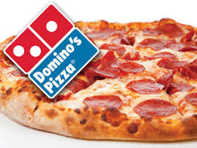

Student Appreciation Lunch 2018!!!
Thursday, February 1st, 2018
Preschool 4’s-8th Grade
Students will be treated to Domino’s Pizza, courtesy of Incarnation PTO!
Each child will be served a pizza meal consisting of 2 slices of Pizza (pepperoni or cheese), chips, and water.
If your child would like more to eat, please pack extra food for them. Extra slices will not be sold.
The cafeteria will not be open serving lunch that day. If your child will not be eating the pizza lunch provided, you must pack your own lunch.
Students will have the option to receive milk.

If you would like to volunteer this day, please contact Ellen Miller at 937-433-1051 ext. 148 or ellen.miller@incarnation-school.com This will be a casual dress day.

